**Attachment 1**

**Scope of Work for Coating of Winston Cones**

1. **General Description.**

A Winston cone (WC) is a non-imaging light collector designed to reflect light from a range of incident angles on a given circular area and “collect” that light onto a smaller area. Its general shape is that of a parabola that revolves about its axis of symmetry.

There are 216 WC in the Low Threshold Cerenkov Counter (LTCC). The general shape is shown in Fig.1. Two sides are flat and parallel, two sides have parabolic shape. There are three types of WC:

* Small:
  + Height: 18cm
  + Parallel Plate distance: 14cm
  + Radius at the top: 20cm
  + Radius at the bottom: 11cm
  + Material: copper (electro-formed)
* Medium:
  + Height: 22cm
  + Parallel Plate distance: 15cm
  + Radius at the top: 20cm
  + Radius at the bottom: 11cm
  + Material: 0.2” plastic (vacuum pressed)
* Large:
  + Height: 30cm
  + Parallel Plate distance: 18cm
  + Radius at the top: 22cm
  + Radius at the bottom: 11cm
  + Material: copper (electro-formed)

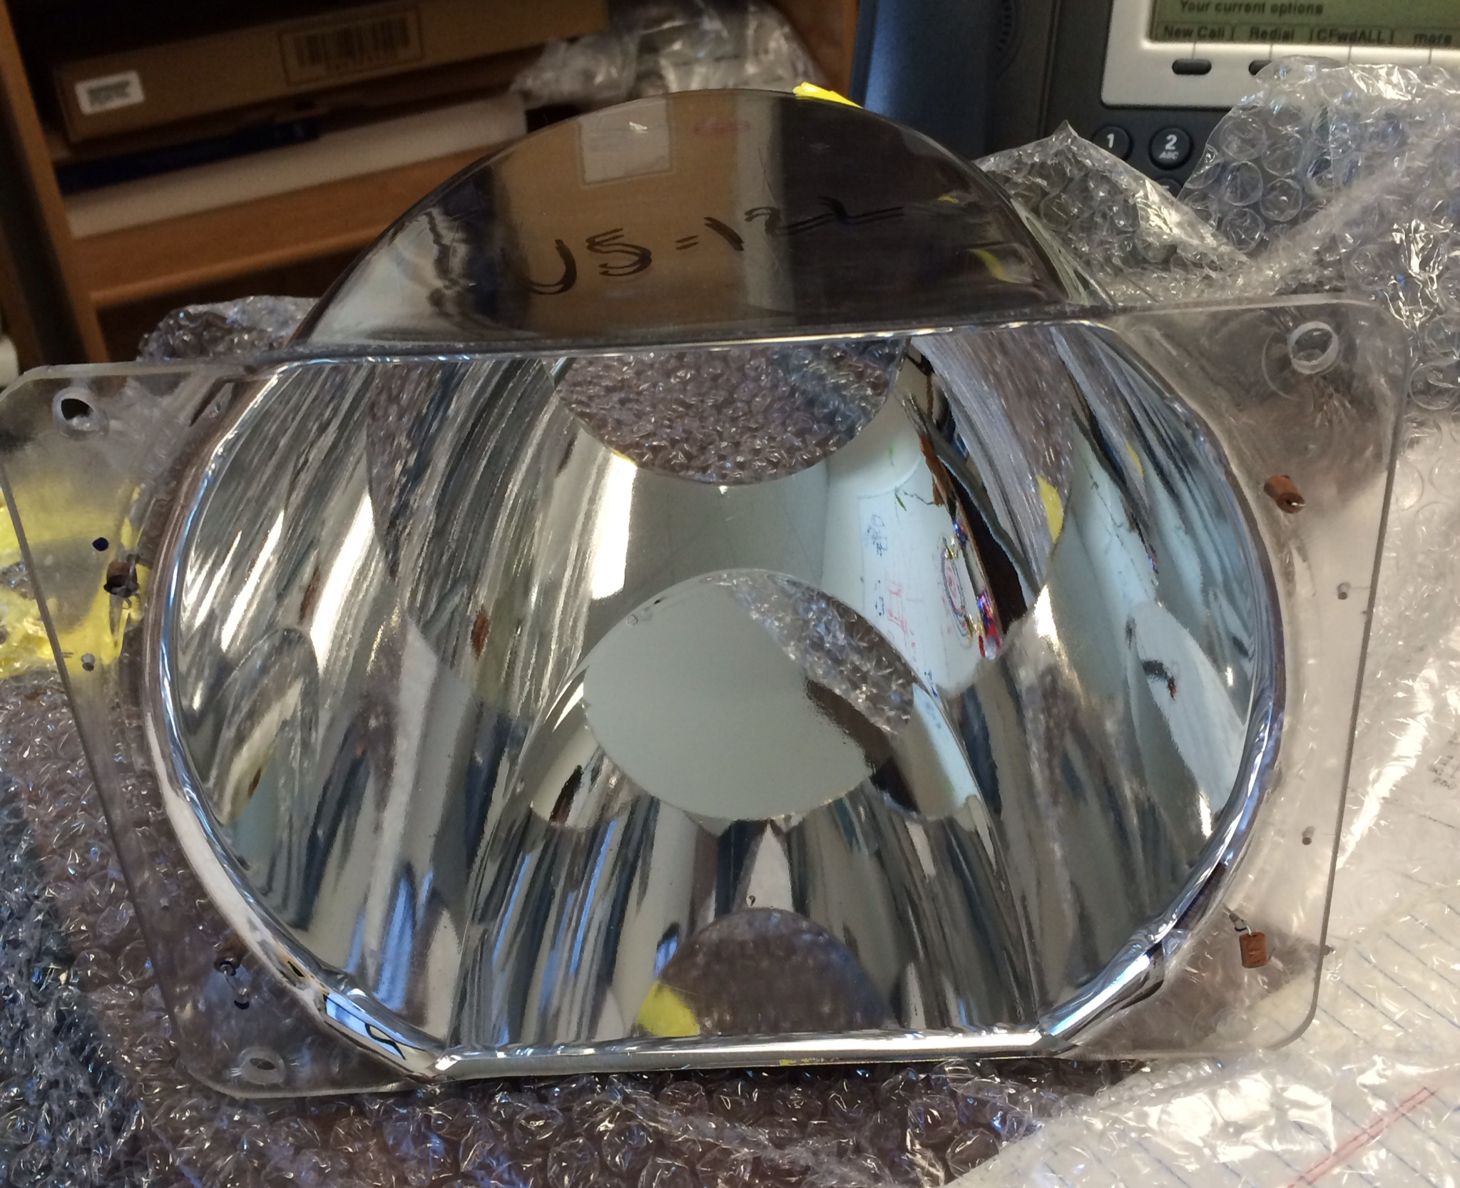

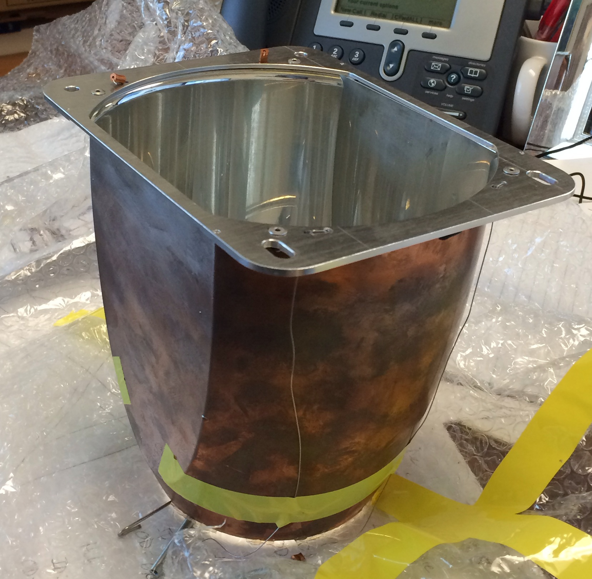

Figure . Top: a medium (plastic) WC. Bottom: a small (Copper) WC

**II. Specifications and Technical Requirements**

**2.1 Definition**

The WC’s inner surfaces were vacuum coated with aluminum to a thickness of about 40 nm, followed by MgF2. The WC were coated approximately 17 years ago with Aluminum + Magnesium Fluoride. The 90% original reflectivity degraded to about 75%. Tests confirmed that re-coating the mirrors with AlMgF2 can restore reflectivity to approximately 90%.

**2.2 Delivery**

The 216 WC’s will be shipped for coating to the vendor in boxes, with 3 or 4 WC’s in each box, filled with appropriate packaging material. Installation of the WC’s at Jefferson Lab is expected to start in March 2014, at a rate of one sector / month. Number of WC’s in each installment, their delivery and testing rates can be modified and established by mutual agreement between Jefferson Lab and the vendor.

**2.3 Coating**

We will require Al reflector coatings and MgF2 protective coatings. The application method for each should be vacuum (vapor) deposition. The coatings are required to meet the conditions of items 2.5.

**2.5 Requirements**

1. A Reflectivity of ~ 88% is required for wavelengths between 200nm and 600nm (Refer Reflectance vs. Wavelength Curve for Protected Aluminum, see Appendix B).
2. We will a no optical degradation warranty if the substrate shows no deterioration.
3. The reflective surface coating shall show no deterioration after a test exposure in air for 24-hours at a temperature of 49oC and 95% relative humidity.
4. The vendor may clean the reflective surface with only optical liquid if needed, but should avoid any other contact of the reflecting surface.
5. The reflecting surface coating should show no damage after 3M Scotch Brand No.610 adhesive tape (or equivalent) is placed against the coated surface and removed slowly.

**2.6 Working Conditions**

Recoated WC’s will be stored in a controlled humidity, clean room environment for a period of about 3 months. The operating working conditions will be in an enclosed volume filled with C4F10 (perfluorobutane) with a maximum net pressure of about 340Pa.

**III. Tests and Quality Assurance**

The vendor will perform direct or indirect checking of reflectance of each WC coated and provide Jefferson Lab with corresponding tests. Coated WC’s will be tested at Jefferson Lab as well to check reflectivity and other parameters as specified in this document and compared with the results provided by the vendor. Surfaces that do not pass the tests will be sent back to the vendor for refurbishing or rejected**.**

**IV. Delivery**

Installation of the surfaces onto the mirrors at Jefferson Lab is expected to start in March 2014, at a rate of one sector / month. The number of WC in each installment, their delivery and testing rates can be modified and established by mutual agreement between Jefferson Lab and the vendor.

**VI. Payment**

Payment for coating of the Winston Cones, completely tested and accepted by Jefferson Lab, can be made upon request, without waiting for completion of coating of all the cones. Other rules and regulations that are standard for all payments made by Jefferson Lab are applicable.

**Appendix A: Schematics of elliptical, hyperbolic, cylindrical mirrors and Winston cones.**

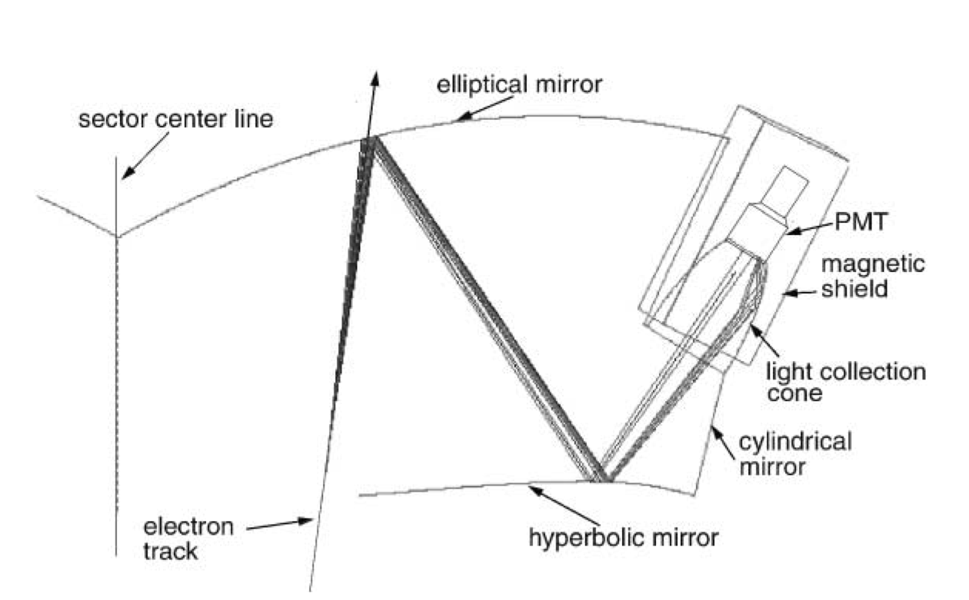

**Appendix B: Reflectance of (Al)MgF2 Coating as a Function of Wavelength**

